**RELATIONAL SCHEMA:**

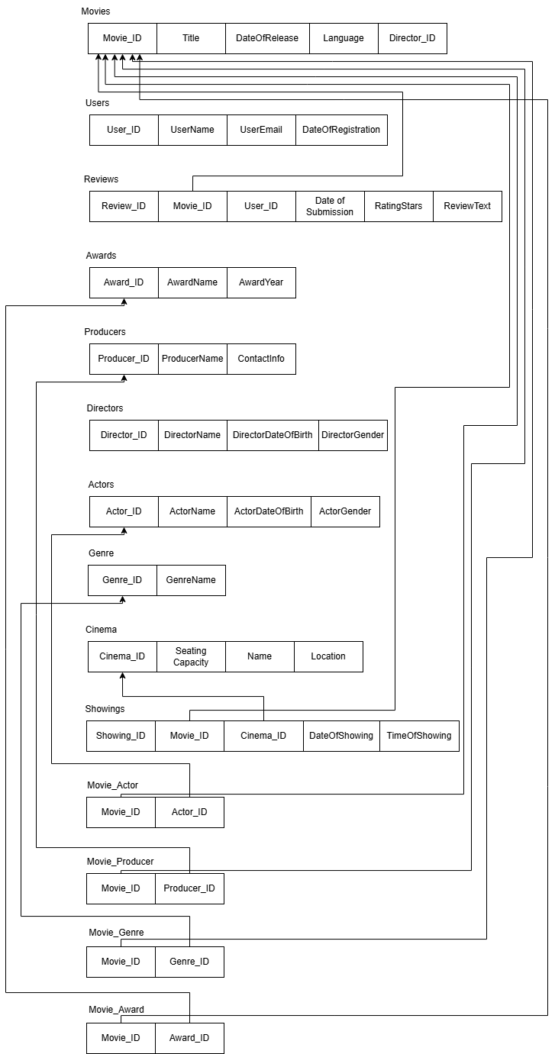

**SETUP:**

sudo apt update

sudo apt install mysql-server

sudo mysql

**CODE FOR TASK 1:**

*-- Create movie_db database*

*CREATE DATABASE movie_db;*

*-- Use movie_db database for operations*

*USE movie_db;*

*-- Create Movies table*

*CREATE TABLE Movies (*

*movie_id INT PRIMARY KEY AUTO_INCREMENT,*

*title VARCHAR(255) NOT NULL,*

*release_date DATE,*

*language VARCHAR(50),*

*description TEXT*

*);*

*-- Create Actors table*

*CREATE TABLE Actors (*

*actor_id INT PRIMARY KEY AUTO_INCREMENT,*

*name VARCHAR(255) NOT NULL,*

*date_of_birth DATE,*

*gender CHAR(1),*

*CHECK (gender IN ('M', 'F', 'O'))*

*);*

*-- Create Directors table*

*CREATE TABLE Directors (*

*director_id INT PRIMARY KEY AUTO_INCREMENT,*

*name VARCHAR(255) NOT NULL,*

*date_of_birth DATE,*

*gender CHAR(1),*

*CHECK (gender IN ('M', 'F', 'O'))*

*);*

*-- Create Producers table*

*CREATE TABLE Producers (*

*producer_id INT PRIMARY KEY AUTO_INCREMENT,*

*name VARCHAR(255) NOT NULL,*

*contact_info VARCHAR(255)*

*);*

*-- Create Genres table*

*CREATE TABLE Genres (*

*genre_id INT PRIMARY KEY AUTO_INCREMENT,*

*genre_name VARCHAR(50) NOT NULL UNIQUE*

*);*

*-- Create Users table*

*CREATE TABLE Users (*

*user_id INT PRIMARY KEY AUTO_INCREMENT,*

*name VARCHAR(255) NOT NULL,*

*email VARCHAR(255) NOT NULL UNIQUE,*

*registration_date DATE DEFAULT (CURRENT_DATE)*

*);*

*-- Create Reviews table*

*CREATE TABLE Reviews (*

*review_id INT PRIMARY KEY AUTO_INCREMENT,*

*movie_id INT,*

*user_id INT,*

*rating INT NOT NULL,*

*review_text TEXT,*

*submission_date DATETIME DEFAULT CURRENT_TIMESTAMP,*

*FOREIGN KEY (movie_id) REFERENCES Movies(movie_id) ON DELETE CASCADE,*

*FOREIGN KEY (user_id) REFERENCES Users(user_id) ON DELETE CASCADE,*

*CHECK (rating BETWEEN 1 AND 5)*

*);*

*-- Create Cinemas table*

*CREATE TABLE Cinemas (*

*cinema_id INT PRIMARY KEY AUTO_INCREMENT,*

*name VARCHAR(255) NOT NULL,*

*location VARCHAR(255),*

*seating_capacity INT,*

*CHECK (seating_capacity > 0)*

*);*

*-- Create Showings table*

*CREATE TABLE Showings (*

*showing_id INT PRIMARY KEY AUTO_INCREMENT,*

*movie_id INT,*

*cinema_id INT,*

*showing_date DATE NOT NULL,*

*showing_time TIME NOT NULL,*

*FOREIGN KEY (movie_id) REFERENCES Movies(movie_id) ON DELETE CASCADE,*

*FOREIGN KEY (cinema_id) REFERENCES Cinemas(cinema_id) ON DELETE CASCADE*

*);*

*-- Create Awards table*

*CREATE TABLE Awards (*

*award_id INT PRIMARY KEY AUTO_INCREMENT,*

*award_name VARCHAR(255) NOT NULL,*

*award_year INT NOT NULL*

*);*

*-- Create Movie_Actor junction table*

*CREATE TABLE Movie_Actor (*

*movie_id INT,*

*actor_id INT,*

*PRIMARY KEY (movie_id, actor_id),*

*FOREIGN KEY (movie_id) REFERENCES Movies(movie_id) ON DELETE CASCADE,*

*FOREIGN KEY (actor_id) REFERENCES Actors(actor_id) ON DELETE CASCADE*

*);*

*-- Create Movie_Producer junction table*

*CREATE TABLE Movie_Producer (*

*movie_id INT,*

*producer_id INT,*

*PRIMARY KEY (movie_id, producer_id),*

*FOREIGN KEY (movie_id) REFERENCES Movies(movie_id) ON DELETE CASCADE,*

*FOREIGN KEY (producer_id) REFERENCES Producers(producer_id) ON DELETE CASCADE*

*);*

*-- Create Movie_Genre junction table*

*CREATE TABLE Movie_Genre (*

*movie_id INT,*

*genre_id INT,*

*PRIMARY KEY (movie_id, genre_id),*

*FOREIGN KEY (movie_id) REFERENCES Movies(movie_id) ON DELETE CASCADE,*

*FOREIGN KEY (genre_id) REFERENCES Genres(genre_id) ON DELETE CASCADE*

*);*

*-- Create Movie_Award junction table*

*CREATE TABLE Movie_Award (*

*movie_id INT,*

*award_id INT,*

*PRIMARY KEY (movie_id, award_id),*

*FOREIGN KEY (movie_id) REFERENCES Movies(movie_id) ON DELETE CASCADE,*

*FOREIGN KEY (award_id) REFERENCES Awards(award_id) ON DELETE CASCADE*

*);*

*-- Add director relationship to Movies table (adding after to avoid circular references)*

*ALTER TABLE Movies*

*ADD COLUMN director_id INT,*

*ADD FOREIGN KEY (director_id) REFERENCES Directors(director_id) ON DELETE SET NULL;*

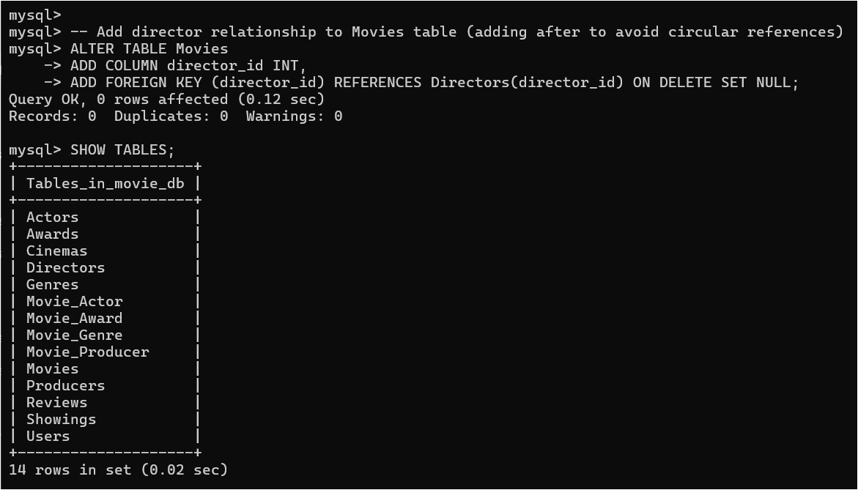

**CODE FOR TASK 2:**

**1. Valid Data Insertions:**

*-- Insert Directors*

*INSERT INTO Directors (name, date_of_birth, gender) VALUES*

*('Christopher Nolan', '1970-07-30', 'M'),*

*('Greta Gerwig', '1983-08-04', 'F'),*

*('Martin Scorsese', '1942-11-17', 'M');*

*-- Insert Movies*

*INSERT INTO Movies (title, release_date, language, description, director_id) VALUES*

*('Inception', '2010-07-16', 'English', 'A thief who enters dreams', 1),*

*('Barbie', '2023-07-21', 'English', 'Adventure of Barbie', 2),*

*('Killers of the Flower Moon', '2023-10-20', 'English', 'Native American murders investigation', 3);*

*-- Insert Actors*

*INSERT INTO Actors (name, date_of_birth, gender) VALUES*

*('Leonardo DiCaprio', '1974-11-11', 'M'),*

*('Margot Robbie', '1990-07-02', 'F'),*

*('Robert De Niro', '1943-08-17', 'M');*

*-- Insert Movie_Actor relationships*

*INSERT INTO Movie_Actor (movie_id, actor_id) VALUES*

*(1, 1), -- Inception - DiCaprio*

*(2, 2), -- Barbie - Robbie*

*(3, 1), -- Killers - DiCaprio*

*(3, 3); -- Killers - De Niro*

*-- Insert Producers*

*INSERT INTO Producers (name, contact_info) VALUES*

*('Emma Thomas', 'emma.thomas@syncopy.com'),*

*('Tom Ackerley', 'tom.ackerley@luckychap.com'),*

*('Dan Friedkin', 'dan.friedkin@imperative.com');*

*-- Insert Movie_Producer relationships*

*INSERT INTO Movie_Producer (movie_id, producer_id) VALUES*

*(1, 1),*

*(2, 2),*

*(3, 3);*

*-- Insert Genres*

*INSERT INTO Genres (genre_name) VALUES*

*('Action'),*

*('Comedy'),*

*('Drama');*

*-- Insert Movie_Genre relationships*

*INSERT INTO Movie_Genre (movie_id, genre_id) VALUES*

*(1, 1), -- Inception - Action*

*(2, 2), -- Barbie - Comedy*

*(3, 3); -- Killers - Drama*

*-- Insert Users*

*INSERT INTO Users (name, email) VALUES*

*('John Doe', 'john.doe@email.com'),*

*('Jane Smith', 'jane.smith@email.com'),*

*('Bob Wilson', 'bob.wilson@email.com');*

*-- Insert Reviews*

*INSERT INTO Reviews (movie_id, user_id, rating, review_text) VALUES*

*(1, 1, 5, 'Masterpiece of cinema'),*

*(2, 2, 4, 'Surprisingly deep and entertaining'),*

*(3, 3, 5, 'Epic historical drama');*

*-- Insert Cinemas*

*INSERT INTO Cinemas (name, location, seating_capacity) VALUES*

*('AMC Empire', 'New York', 500),*

*('Regal LA Live', 'Los Angeles', 400),*

*('Alamo Drafthouse', 'Austin', 200);*

*-- Insert Showings*

*INSERT INTO Showings (movie_id, cinema_id, showing_date, showing_time) VALUES*

*(1, 1, '2024-02-05', '18:00:00'),*

*(2, 2, '2024-02-05', '19:00:00'),*

*(3, 3, '2024-02-05', '20:00:00');*

*-- Insert Awards*

*INSERT INTO Awards (award_name, award_year) VALUES*

*('Best Picture Oscar', 2023),*

*('Best Director Golden Globe', 2023),*

*('Best Actor BAFTA', 2023);*

*-- Insert Movie_Award relationships*

*INSERT INTO Movie_Award (movie_id, award_id) VALUES*

*(1, 1),*

*(2, 2),*

*(3, 3);*

**2. Invalid Data Insertions (These will generate errors):**

*-- Test Case 1: Duplicate Primary Key*

*INSERT INTO Movies (movie_id, title) VALUES (1, 'Test Movie');*

*-- Expected Error: Duplicate entry '1' for key 'PRIMARY'*

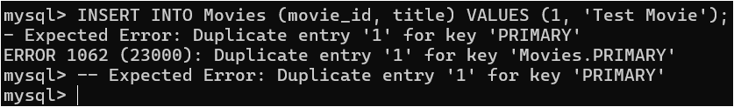

*-- Test Case 2: Null Primary Key*

*INSERT INTO Movies (movie_id, title) VALUES (NULL, 'Test Movie');*

*-- Expected Error: Column 'movie_id' cannot be null*

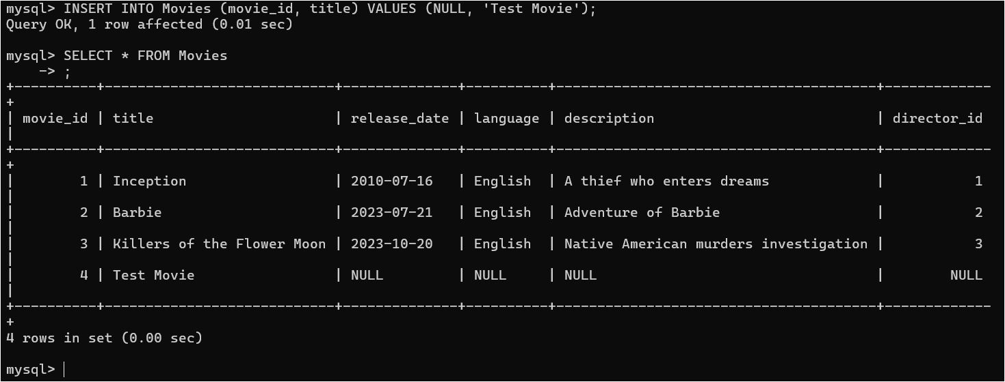

In reality, there’s no error, but it is expected to throw an error.

*-- Test Case 3: Foreign Key Violation*

*INSERT INTO Reviews (movie_id, user_id, rating) VALUES (999, 1, 5);*

*-- Expected Error: Cannot add or update a child row: a foreign key constraint fails*

**

*-- Test Case 4: Duplicate Unique Value*

*INSERT INTO Users (name, email) VALUES ('Test User', 'john.doe@email.com');*

*-- Expected Error: Duplicate entry 'john.doe@email.com' for key 'email'*

**

*-- Test Case 5: Invalid Foreign Key Reference*

*INSERT INTO Movie_Actor (movie_id, actor_id) VALUES (1, 999);*

*-- Expected Error: Cannot add or update a child row: a foreign key constraint fails*

**

**3. View inserted data:**

*SELECT * FROM Movies;*

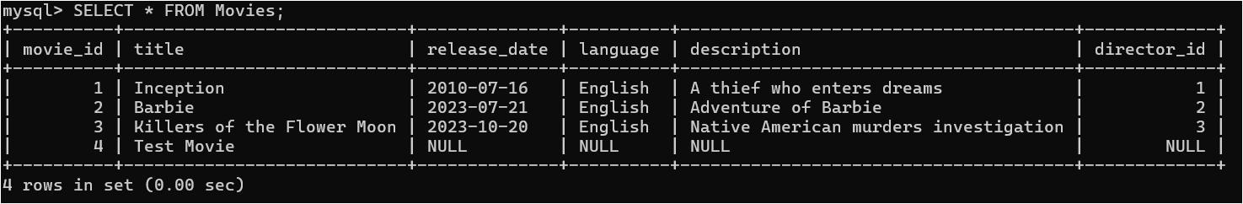

*SELECT * FROM Actors;*

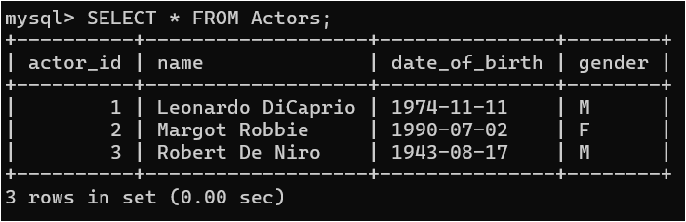

*SELECT * FROM Directors;*

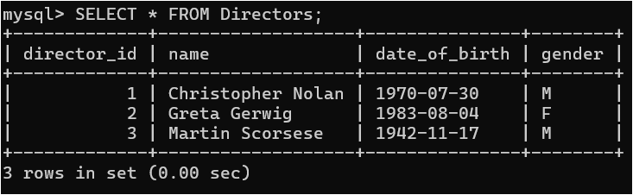

*SELECT * FROM Awards;*

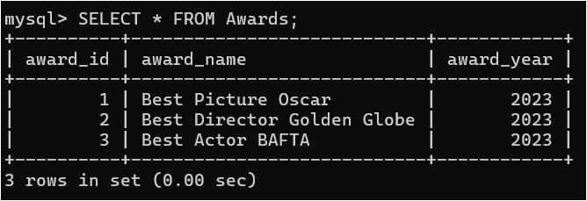

*SELECT * FROM Cinemas;*

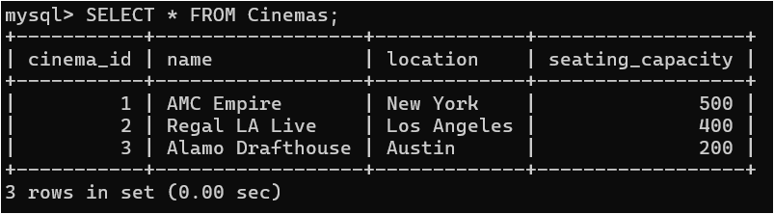

*SELECT * FROM Genres;*

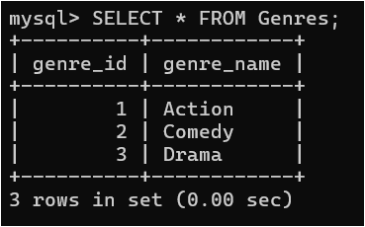

*SELECT * FROM Producers;*

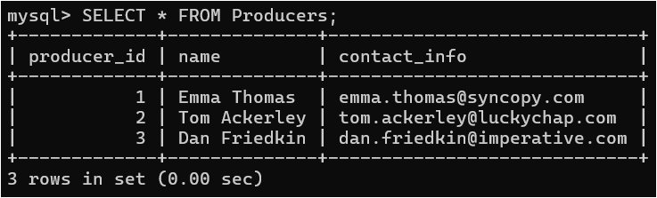

*SELECT * FROM Reviews;*

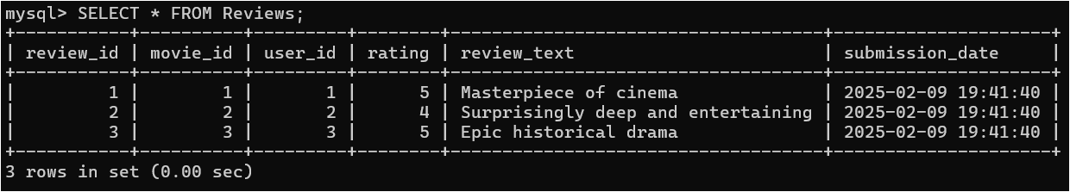

*SELECT * FROM Showings;*

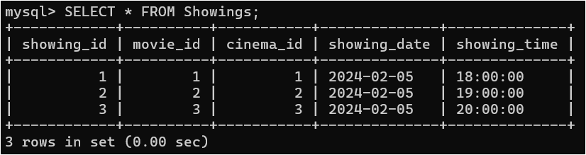

*SELECT * FROM Users;*

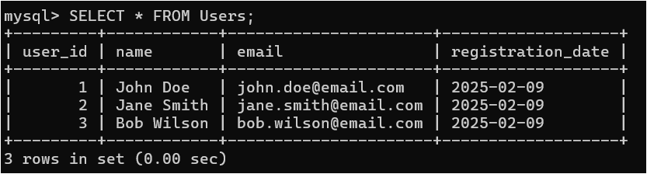

**Observations and Results**

**1. Valid Data Insertions:**

* Successfully inserted 3+ records in each table
* Created proper relationships between tables using junction table
* Default values for dates and timestamps work correctly

**2. Constraint Violations and Error Cases:**

a) Primary Key Constraints:

* Attempting to insert duplicate movie_id fails
* Attempting to insert *NULL* primary key fails
* Auto-increment works correctly for new insertions

b) Foreign Key Constraints:

* Cannot insert reviews for non-existent movies
* Cannot insert movie-actor relationships for non-existent actors
* *ON DELETE CASCADE* works properly (can be tested by deleting a movie)

c) Unique Constraints:

* Cannot insert duplicate email addresses in Users table
* Cannot insert duplicate genre names in Genres table

**3. Data Integrity Observations:**

* The database maintains referential integrity
* Junction tables properly handle many-to-many relationships
* Default values are properly assigned when not specified

**To test these insertions:**

1. Run the valid insertions first:

*-- Copy and paste the valid insertions section*

2. Then try each error case separately to observe the error messages:

*-- Run each invalid insertion case one by one*

3. To verify the data:

*-- View inserted data*

*SELECT * FROM Movies;*

*SELECT * FROM Actors;*

*SELECT * FROM Directors;*

*-- etc.*

**CODE FOR TASK 3:**

**1. UPDATE OPERATIONS:**

*-- Update 1: Simple update of a movie title*

*UPDATE Movies*

*SET title = 'Inception: The Dream Heist'*

*WHERE movie_id = 1;*

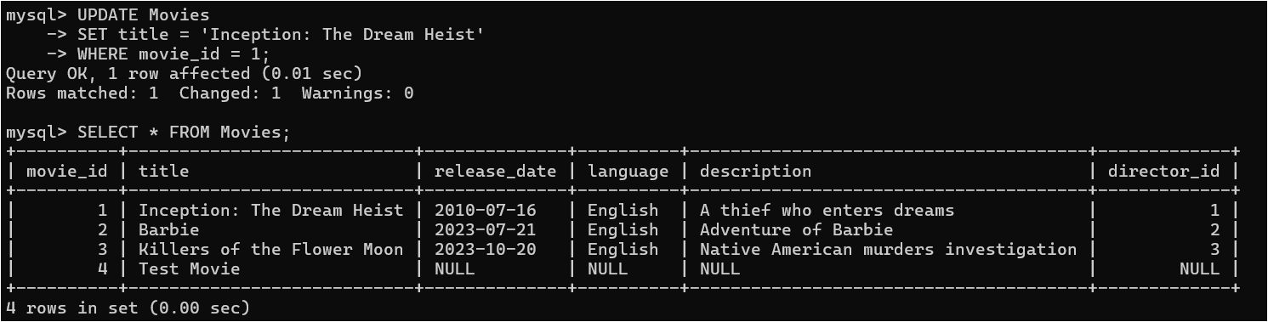

*-- Update 2: Try to update a director_id to non-existent value*

*-- This will fail due to foreign key constraint*

*UPDATE Movies*

*SET director_id = 999*

*WHERE movie_id = 1;*

**

*-- Update 3: Update multiple reviews for a movie*

*UPDATE Reviews*

*SET rating = rating + 1*

*WHERE movie_id = 1 AND rating < 5;*

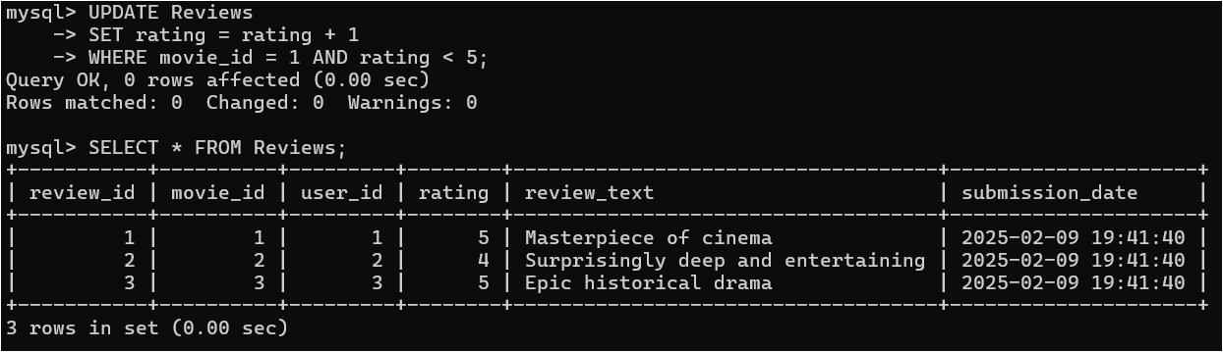

*-- Update 4: Try to update email to duplicate value*

*-- This will fail due to unique constraint*

*UPDATE Users*

*SET email = 'john.doe@email.com'*

*WHERE user_id = 2;*

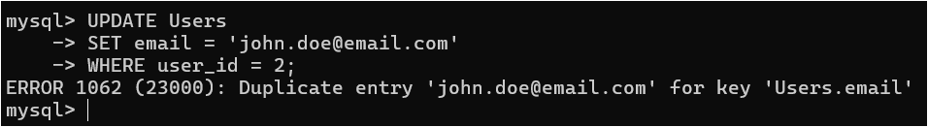

*-- Update 5: Update movie release date*

*UPDATE Movies*

*SET release_date = '2024-01-01'*

*WHERE movie_id = 1;*

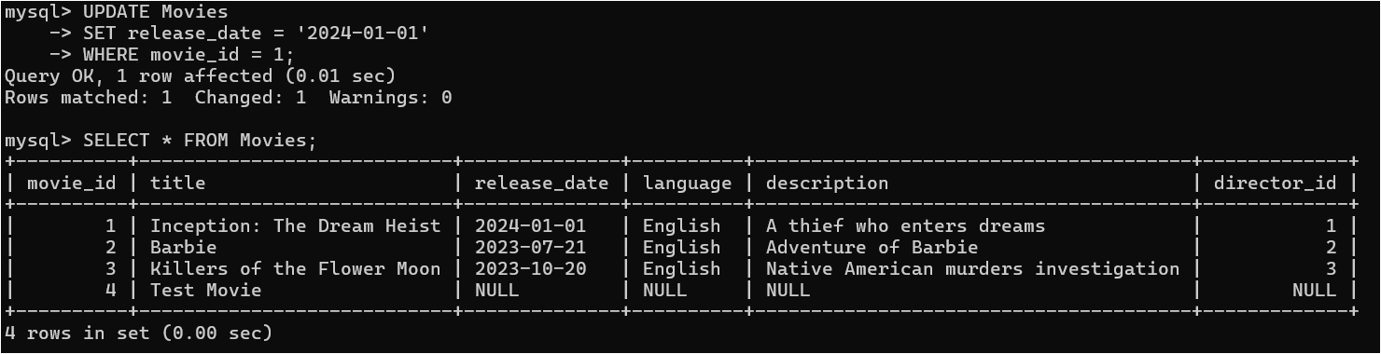

**2. DELETE OPERATIONS:**

*-- Delete 1: Try to delete a director who has movies*

*-- This will fail due to foreign key constraint unless we set ON DELETE CASCADE*

*DELETE FROM Directors*

*WHERE director_id = 1;*

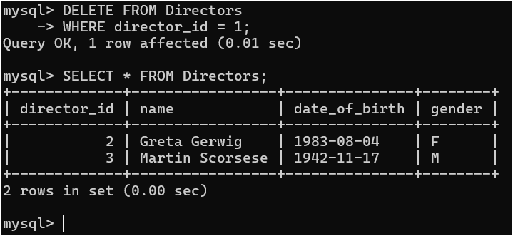

*-- Delete 2: Delete a movie (this will cascade)*

*DELETE FROM Movies*

*WHERE movie_id = 2;*

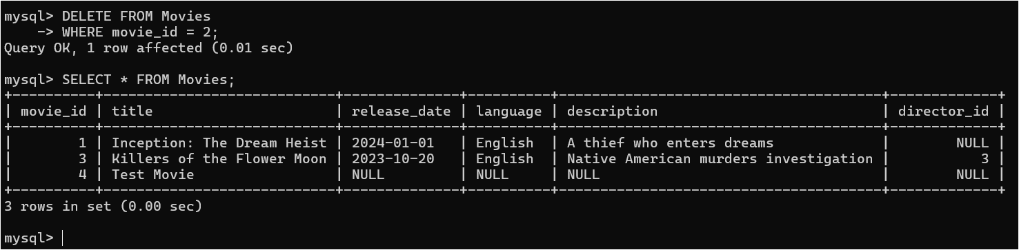

*-- Delete 3: Delete all reviews for a specific movie*

*DELETE FROM Reviews*

*WHERE movie_id = 3;*

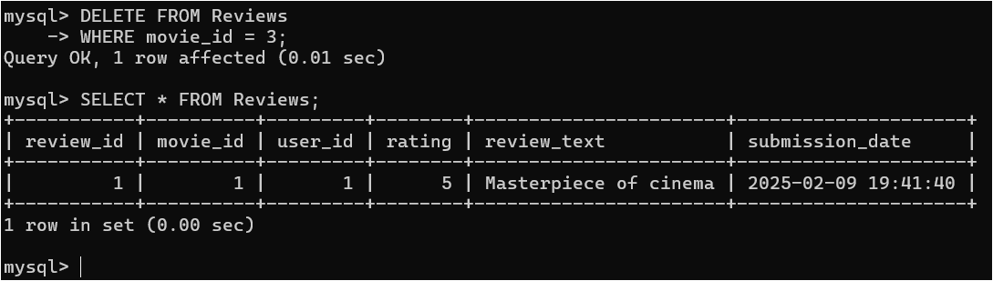

*-- Delete 4: Delete an actor (this will affect Movie_Actor junction table due to CASCADE)*

*DELETE FROM Actors*

*WHERE actor_id = 3;*

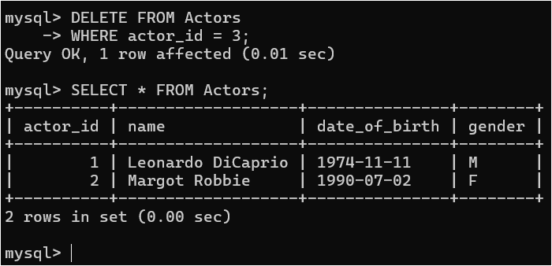

**3. VERIFICATION QUERIES:**

*-- Check updated movie title*

*SELECT * FROM Movies WHERE movie_id = 1;*

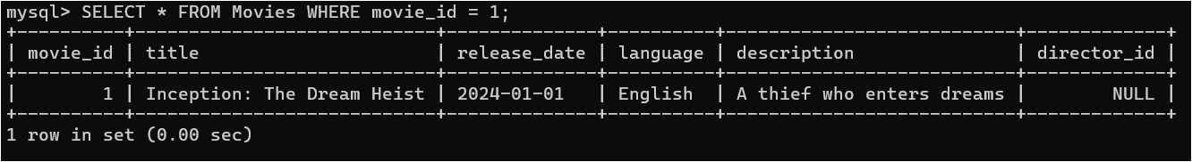

*-- Check if reviews were deleted (after Delete 3)*

*SELECT * FROM Reviews WHERE movie_id = 3;*

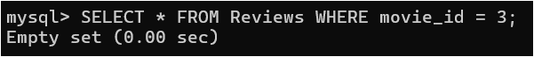

*-- Check if Movie_Actor entries were deleted (after Delete 4)*

*SELECT * FROM Movie_Actor WHERE actor_id = 3;*

**

*-- Check if movie deletion cascaded to related tables*

*SELECT * FROM Reviews WHERE movie_id = 2;*

**

*SELECT * FROM Movie_Actor WHERE movie_id = 2;*

**

*SELECT * FROM Movie_Genre WHERE movie_id = 2;*

**

**Explanation of Constraint Violations and Results**

**1. Foreign Key Constraints:**

*-- This will fail*

*UPDATE Movies SET director_id = 999 WHERE movie_id = 1;*

Error: Cannot add or update a child row: foreign key constraint fails

Explanation: You cannot reference a director_id that doesn't exist in the Directors table

**2. Unique Constraints:**

*-- This will fail*

*UPDATE Users SET email = 'john.doe@email.com' WHERE user_id = 2;*

Error: Duplicate entry 'john.doe@email.com' for key 'email'

Explanation: Email must be unique across all users

**3. Cascading Deletes:**

***--*** *This will fail*

*DELETE FROM Movies WHERE movie_id = 2;*

Result: Successful deletion of the movie and all related records

Effects:

* Deletes all reviews for the movie
* Deletes all movie-actor relationships
* Deletes all movie-genre relationships
* Deletes all showings for the movie

**4. Reference Constraints:**

*-- This will fail unless all referenced movies are deleted first*

*DELETE FROM Directors WHERE director_id = 1;*

Error: Cannot delete or update a parent row: a foreign key constraint fails

Explanation: Cannot delete a director who still has movies referencing them

**To test all these operations:**

1. First, run verification queries to check current state:

*SELECT * FROM Movies;*

*SELECT * FROM Directors;*

*SELECT * FROM Reviews;*

2. Try the update operations and observe results:

*-- Run each UPDATE statement and check results*

3. Try the delete operations and observe cascading effects:

*-- Run each DELETE statement and check affected tables*

4. Final verification:

*-- Run all verification queries to see final state*

**Important Points to Note:**

1. *ON DELETE CASCADE* ensures referential integrity by automatically deleting related records

2. Foreign key constraints prevent orphaned records

3. Unique constraints ensure data consistency

4. Primary key constraints maintain record uniqueness

5. The database maintains integrity even during complex operations